**Govt. College of Nursing, GSVM medical college Campus, Kanpur**

**REPORT**

**ON**

**“ANTI RAGGING WEEK CELEBRATION”**

**Prepared By**

**Mrs. Ranjna Singh Rajpoot**

**Assistant Professor**

**College of Nursing, Kanpur**

**‘’REPORT ON ANTI RAGGING WEEK CELEBRATION’’**

**Date –** 12/08/2024 -17/08/2024 **Time –** 2 to 4 PM

**Venue –** WAC Hall

In Reference to UGC New Delhi letter No. 1-15/2009 (ARC) Pt. III Anti Ragging Week was celebrated in the Govt. College of Nursing, GSVM Medical College Campus, Kanpur from 12-08-2024 to 17-08-2024 at WAC Hall between 2-4 pm, The Schedule of the Programme was as follows –

**SCHEDULE FOR ANTI RAGGING WEEK (12.08.24 to 17.08.24)**

|  |  |  |  |  |  |
| --- | --- | --- | --- | --- | --- |
| **S. No** | **Programme** | **Date** | **Faculty responsible** | **Judges** | **Time** |
| 1 | Orientation/  Induction | 12.08.24 | Committee members | -- | 2-4 PM |
| 2 | Slogan Competition | 13.08.24 | Mrs. Meenakshi Singh | 1. Mrs. Lithiya Jose 2. Dr. Akansha Massey | 2-4 PM |
| 3 | Essay Competition | 14.08.24 | Mr. Anil Prajapat | 1. Dr. Naveena J.H 2. Dr. Beena Peter | 2-4 PM |
| 4 | Poster making Competition | 16.08.24 | Mrs. Itisha Rose Prasad | 1. Prof. NamitaBatra 2. Ms. Manisha Anand | 2-4 PM |
| 5 | Movie/Video on Anti ragging | 17.08.24 | Mrs. Nisha Yadav | -- | 2-4 PM |

Govt. College of Nursing, Kanpur has conducted an orientation program for the consequences of Ragging and have formulated anti ragging committee at college level and contact numbers of all the members were displayed on the notice board and informed to all the students. Members of Anti Ragging committee are as follows;

**ANTI RAGGING COMMITTEE**

**CHAIRPERSON** – **Lt. Col. Dr. Karesh Prasad**, Principal, College of Nursing, Kanpur

**MEMBERS** –

1. **Dr. Ram Kumar**, Assistant Professor, College of Nursing, Kanpur
2. **Mrs. Ranjna Singh Rajpoot**, Assistant Professor, College of Nursing, Kanpur
3. **Mrs. Pushpa Yadav**, Nursing Tutor, College of Nursing, Kanpur

On the Day 1st (12-08-2024), Orientation / Induction was done among Fresher’s and Seniors. During Orientation/Induction, All the students of B.Sc. (N), PB BSc. (N), M.Sc. (N), Chairperson Anti Ragging Committee, **Dr. Karesh Prasad**, Principal, Anti Ragging Member **Dr. Ram Kumar**, Assistant Professor, **Mrs. Ranjna Singh Rajpoot**, Assistant Professor, College of Nursing Kanpur were Present. Orientation session was started by Dr. Ram Kumar, He has discussed about different Ragging Activity and their management Modalities. After that **Mrs. Ranjna Singh Rajpoot,** continues the session and discussed about Administrative Actions to be taken for Ragging and from where victims can take help. Apart from this shared Helpline No and email id among students to register complaints if any one feels to be ragged. A Formal Introduction of Fresher’s & seniors was also done. Dr. Karesh Prasad, Principal, College of Nursing, Kanpur expressed Past and present scenario of Ragging and provide assurance to the new comer students that our campus is Ragging Free. Chairperson also added on discipline, code of conduct, rules and regulation and institution’s aim of ragging free campus. At the end Pledge regarding Anti Ragging was taken by all the students.

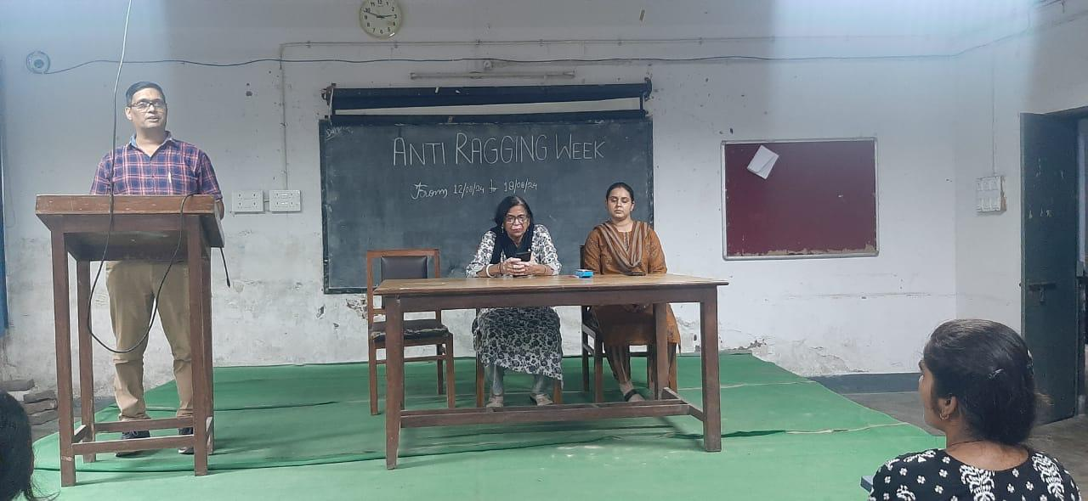 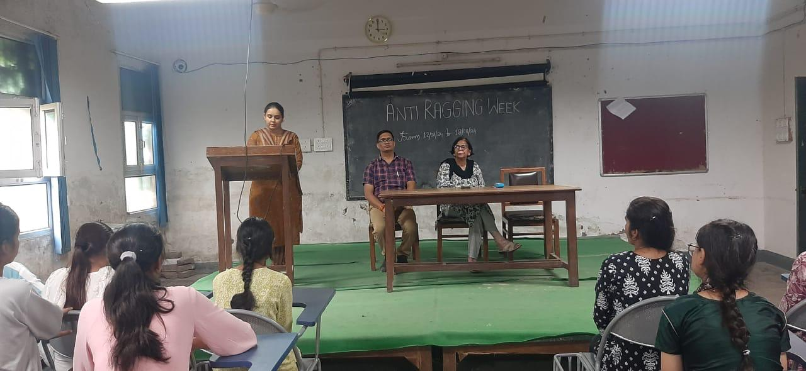

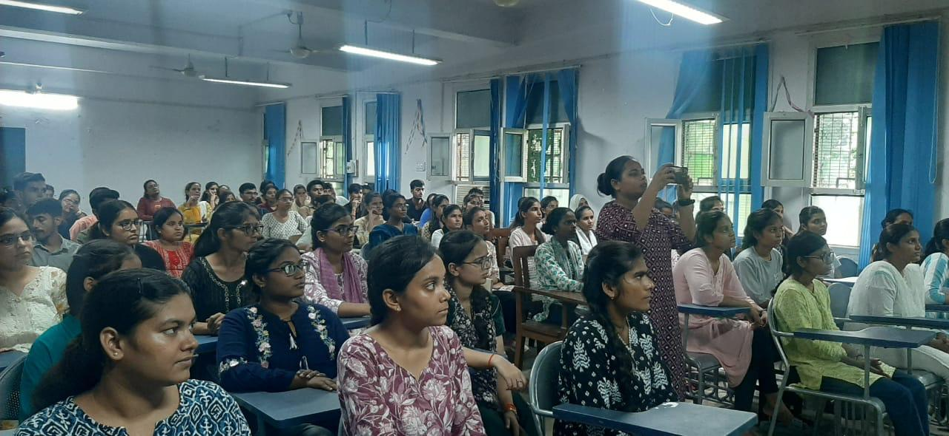 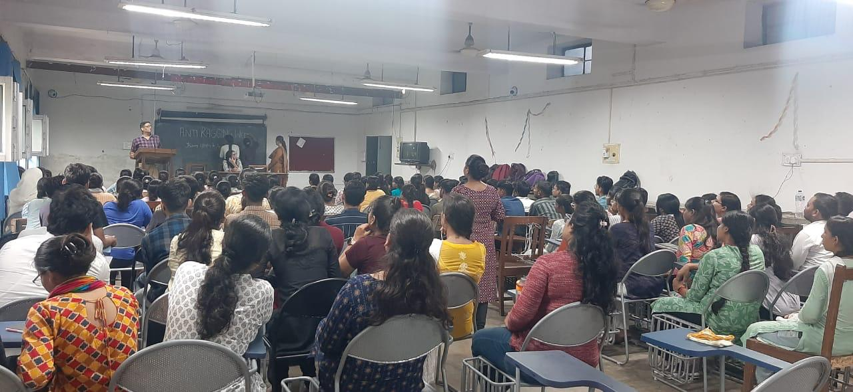

On the Day 2nd (13-08-2024), **Slogan Competition** regarding Anti Ragging was organized among Fresher’s as well as Senior Students. This event was organized by **Mrs. Meenakshi Singh**, Tutor College of Nursing Kanpur. Total No. of students participated in this event was 10. The Slogan Competition event was evaluated by **Mrs. Lithiya Jose**, Associate Professor and **Dr. Akansha Massey**, Tutor College of Nursing, Kanpur. Students presented a very informative message through the slogan regarding Anti Ragging. The Winner of Slogan competition was Tabinda Khan, M.Sc. (N) 2nd Year (1st), Umme Hani Khan, P.B.B.Sc.(N) IInd Year, (2nd), & Shraddha Maurya, B.Sc. (N) 5th Semester got (3rd). Winners were appreciated by providing Certificates.

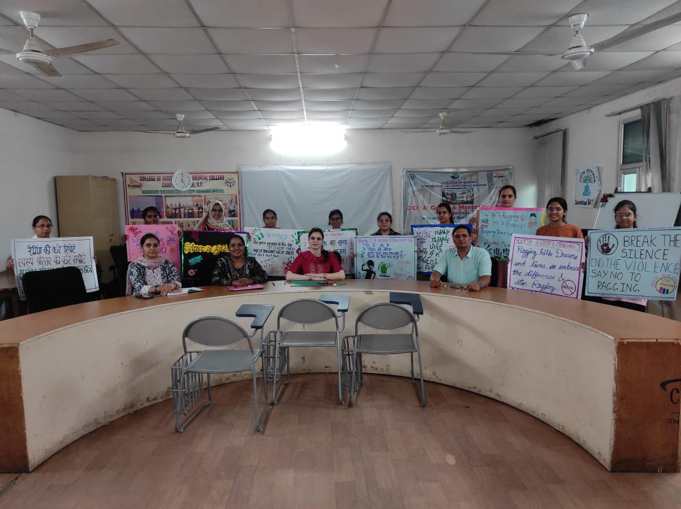 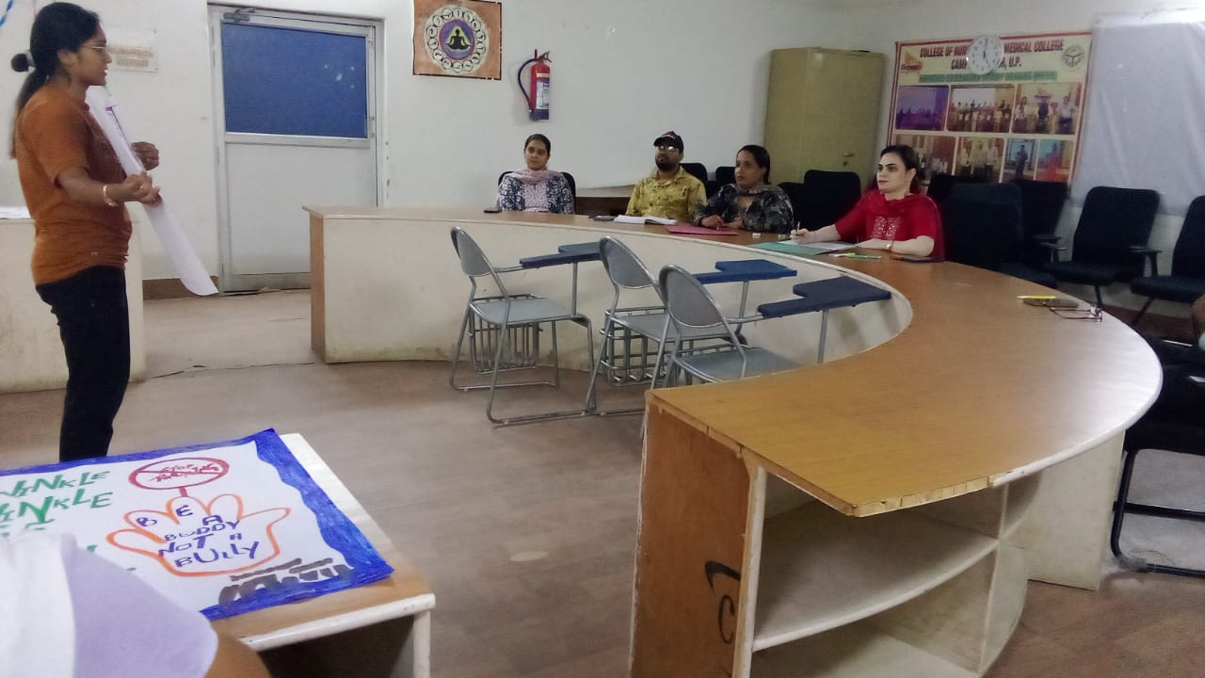

On the Day 3rd (14-08-2024), **Essay Writing Competition** regarding Anti Ragging was organized among Fresher’s and Senior Students. Total 16 students participated in this competition. **Mr. Anil Prajapat** was the organizer of this competition. Judges for this competition were **Dr**. **Naveena J.H**., Vice Principal and **Mrs. Renu Tripathi**, Tutor, College of Nursing Kanpur. Students JahnviVerma (B.Sc. Nursing 3rd Semester) and Anjali Bind (PB B. Sc. Nursing 1st Year) got 1st Position, Pooja Yadav (PB B.Sc. Nursing 1st Year) and Abhilasha Singh (B.Sc. Nursing 1st Semester) got 2ndPosition and Sushmita Mishra (M. Sc. Nursing 2nd Year) got 3rd Position. All the winners have been presented with certificates.

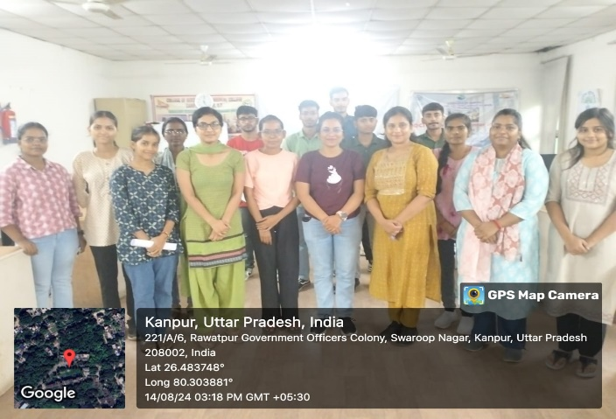 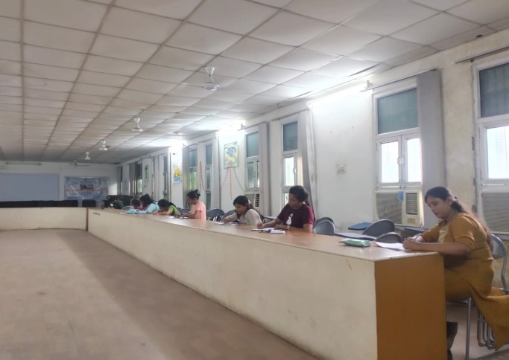

On the Day 4th (16-08-2024), As a part of Anti Ragging Week Celebration, **Poster Making Competition** was organized among Fresher’s and Senior Students. This Competition was organized by **Mrs. Itisha Rose Prasad**, Tutor, College of Nursing, Kanpur. Both new comers and senior students participated actively in this competition. Total 09 students participated. This competition was evaluated by **Prof. Namita Batra** and **Ms. Manisha Anand**, Assistant Professor, College of Nursing, Kanpur. First position was secured by Anushka (M.Sc. Nursing 1st Year), Tanya (B.Sc. Nursing 5th Semester) and Krishna (B. Sc. Nursing 3rd Semester) got 2nd position and Shreya (M.Sc, Nursing 2nd Year) got 3rdposition. Participants h made very informative, attractive and innovative posters.

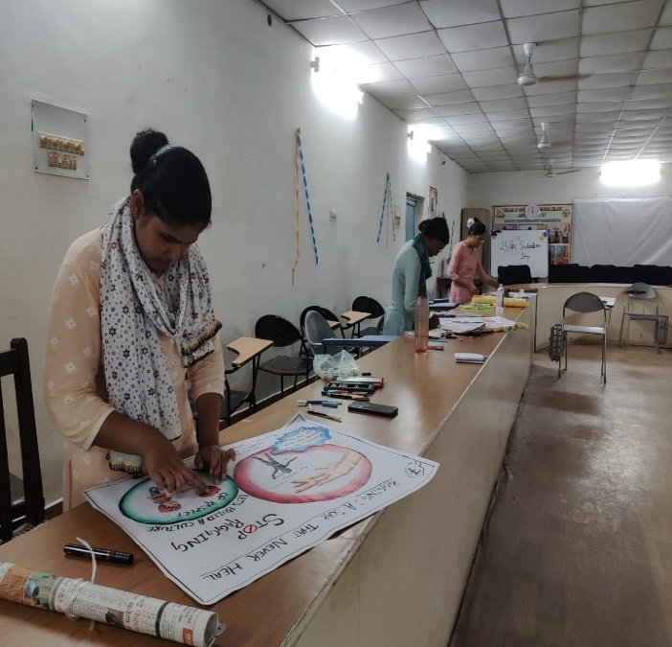 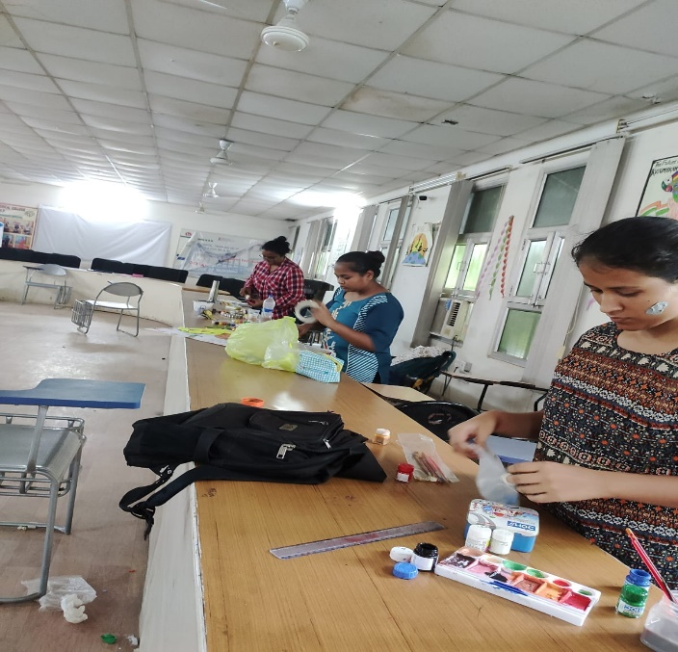

On the Day 5th (17-08-2024), A **Short Movie and Video clips** on Anti Ragging were played for students. This event was organized by **Mrs. Nisha Yadav**, Tutor College of Nursing, Kanpur. Movie delivered lots of messages like what is Ragging, what is different Ragging activity and how it can be prevented. It was very informative and effective session especially for Fresher’s. A video on anti ragging was prepared by M.Sc. Nursing IInd Year Students and it was played in front of all the students. It was appreciated by all the students and faculty members.

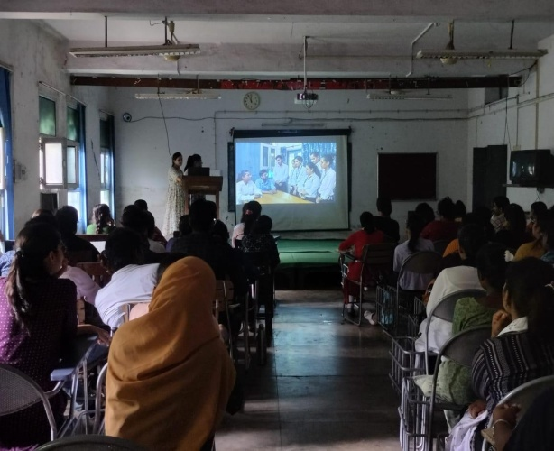 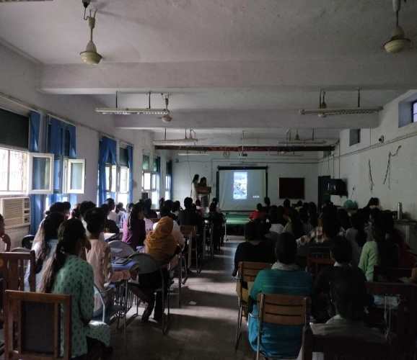

Anti ragging week celebration came to an end on 17.08.2024 with sincere thanks to all the faculty members who have organized the events and students for their active participation in various events.

**Member Anti ragging Principal/Chairperson**